



**INDEX**

**1** **PROJECT DETAILS** 2

**2** **SUMMARY** 2

**3** **INTRODUCTION** 2

3.1 Background 2

3.2 Stakeholders 3

3.3 Objectives 4

**4** **METHODOLOGY** 4

4.1 Considerations & Assumption 3

4.2 Approach 3

4.3 Activities 3

**5** **ACHIEVED OUTPUT** 5

**6** **CONCLUSION** 7

**7** **APPENDICES** 7

7.1 Appendix A – Title 7

**General Instructions for using the Live Project Report Template**

* This template and the subsequent document created using this template is a confidential document and is the intellectual property of Cloud Counselage Pvt. Ltd. Circulating it outside of the organisation without the consent of Cloud Counselage Pvt. Ltd. is the breach of company policies and will lead to legal actions
* This template is a guideline document to communicate the implementation of design ideas and the results of the work to the stakeholders.
* The **text between inequality (< >) is to be replaced** by relevant text
* Please **remove the yellow highlight on the Text** between the inequality (< >). This is done to help you notice the text to be changed/replaced
* The text in *italics* highlighted in grey is just for reference and should be removed after adding the relevant text

# **PROJECT DETAILS**

| **Project Name** | Chris Dsilva | | |
| --- | --- | --- | --- |
| **Project Sponsor** | Tushar Topale | | |
| **Project Manager** | Harshada Topale | | |
| **Start Date** | 19/09/2024 | **Completion Date** | 10/10/2024 |

# **SUMMARY**

*<Explain what the project was expected to deliver, why the project was needed and what the long-term benefits have been or will be. Even though a summary is placed at the beginning of a project report, you can only write it once your entire report is complete.>*

The data analytics project aimed to conduct conduct a thorough analysis of our student interns to understand the correlation between their academic performance, event participation, career aspirations, and success factors, the Data Loading and Preprocessing, Exploratory Data Analysis (EDA), Filtering and Selection and Visualizations were the analytical techniques used to extract meaningful insights. Our findings reveal the insights such as Student Demographics and Participation, Event Popularity, Student Profile Attributes, Event Impact and Geographic Distribution shedding light on trends.

# **INTRODUCTION**

## Background

*<Take this section from the problem statement & the discussion points from requirement elicitation meeting>*

This data analytics project endeavors to address problem of Absence of

insights for the relationship between student's economic background,

academic performance, competence and expected salary , aiming to

leverage data-driven methodologies to uncover valuable insights and

inform decision-making processes. By analyzing the given data, we seek to

uncover patterns, trends, and correlations that can provide deeper

understanding and actionable recommendations. In today's competitive

landscape, the ability to extract actionable insights from data is paramount.

## Stakeholders

*<Take this section from the problem statement & the discussion points from requirement elicitation meeting>*

Stakeholders play crucial roles in any data analytics project. Here's a breakdown of key stakeholders typically involved:

1. Business Leaders/Executives: Business leaders and executives are often the primary stakeholders in data analytics projects. They provide strategic direction, define project objectives, and make decisions based on the insights generated from the analysis.

2. Data Analysts/Data Scientists: Data analysts and data scientists are responsible for conducting the analysis, applying statistical techniques and machine learning algorithms to extract insights from data. They play a pivotal role in transforming raw data into actionable insights.

3.Data Engineers/Data Architects: Data engineers and data architects are involved in the design and implementation of data infrastructure, ensuring that the necessary data pipelines, databases, and data warehouses are in place to support the analytics process.

4. IT Department: The IT department is responsible for providing technical support, managing data security, and ensuring the smooth functioning of IT systems and infrastructure required for the data analytics project.

5. Business Analysts: Business analysts work closely with both business stakeholders and data analysts to understand business requirements, translate them into analytical solutions, and validate the relevance of insights generated from the analysis.

6. Domain Experts/Subject Matter Experts (SMEs): Domain experts or subject matter experts possess in-depth knowledge of the industry or domain being analyzed. They provide valuable domain-specific insights, validate analysis results, and ensure that the findings are relevant and actionable.

7. Regulatory and Compliance Officers: In regulated industries, regulatory and compliance officers ensure that the data analytics project complies with relevant laws, regulations, and industry standards regarding data privacy, security, and ethical use of data.

8. Customers/Clients: In some cases, customers or clients may also be stakeholders in data analytics projects, especially if the analysis aims to improve customer experiences, personalize offerings, or address customer-related issues.

9. External Consultants/Vendors: External consultants or vendors may be engaged to provide specialized expertise, tools, or services to support the data analytics project, especially for complex analyses or advanced analytics capabilities.

## Objectives

*<Reference the objectives in the* ***Project Charter*** *and describe what has been achieved. If there were any changes to the project objectives since the* ***Project Charter*** *was approved/submission they should be documented here.>*

The study aims to analyze student interns' academic performance, event participation, career aspirations, and success factors, with specific objectives. The objectives are as follows

1. Evaluate Academic Performance: The study investigates the relationship between academic performance and student success, career aspirations, leadership roles, and extracurricular activities among higher-performing students.

2. Analyze Event Participation: The study investigates the influence of event participation on student development and success, focusing on factors like academic performance, attendance, correlation with future success, and effective marketing channels for event awareness.

3. Explore Career Aspirations: The study explores students' career goals, their varying salaries, and the influence of factors like family income, academic performance, and leadership experience on their aspirations and desired industries.

4. Assess Factors Influencing Success: Key factors contributing to student success include academic performance, extracurricular involvement, family background, leadership skills, and prior work experience, with family income and leadership skills playing significant roles.

5.Segment Students Based on Success Indicators: The study aims to analyze student success patterns by dividing them into distinct groups based on academic performance, event participation, and career goals, and comparing demographics and achievements.

6. Risk Assessment and Management: Assess and mitigate various risks, such as credit risk, market risk, or operational risk, by analyzing relevant data and developing risk models to support decision-making processes.

7. Compliance and Regulatory Reporting: Ensure compliance with regulatory requirements and reporting standards by analyzing data and generating accurate, timely reports for regulatory bodies and stakeholders.

These objectives can be further refined and tailored to align with the specific needs, challenges, and strategic priorities of the organization or industry undergoing the data analytics project.

# **METHODOLOGY**

Based on the contents of the notebook and the analytical objectives you outlined, here’s a proposed methodology that could be utilized for the analysis of student interns concerning their academic performance, event participation, career aspirations, and influencing factors:

1. Data Collection: Gather data from event participation records, academic performance records, career aspiration surveys, and demographic data to understand an individual's career aspirations and desired job roles.

2. Data Preprocessing: Data cleaning involves handling missing values, normalizing numerical data, and converting categorical data into numerical formats for analysis. It may also involve creating new variables if needed.

3. Exploratory Data Analysis (EDA): Utilize pandas for descriptive statistics and create visualizations like histograms, bar charts, and scatter plots to analyze academic performance, event participation, and career aspirations.

4. Analysis of Relationships: Use correlation analysis to examine academic performance and event participation, group comparisons in pandas, and conduct t-tests or ANOVA to compare means between groups.

5. Predictive Analysis: Utilize regression models to predict outcomes based on predictor variables, and clustering techniques to segment students based on characteristics and participation patterns.

6. Validation of Findings: Cross-validation and statistical significance testing are crucial techniques for ensuring robustness and statistical significance of predictive models.

7. Interpretation of Results: The analysis reveals key insights into relationships, trends, and success predictors, which can be visually represented using dashboards or reports for stakeholder comprehension.

# **ACHIEVED OUTPUT**

*<Mention the targeted output in the project plan and against it what you have been able to achieve. Also mention the reason of deviation. Please remember the deviations will not impact the evaluation and the results of your internship. This sections will help you to analyse the results and understand the cause for deviation that will be lessons learnt for you and would help you to perform better in the next project>*

5.1 Effective Promotion Channel

WhatsApp was found to be the most effective channel for promoting events, attracting 1,067 participants, indicating a strong student preference for messaging platforms.

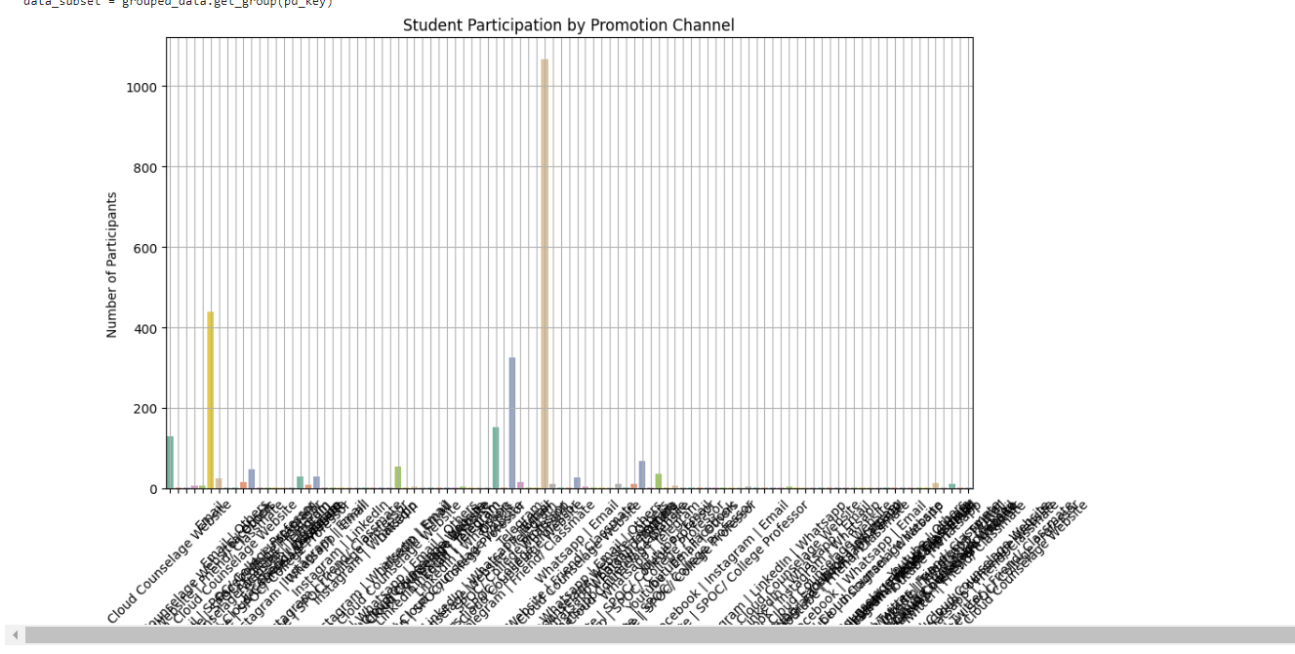

5.2 Participation in Data Science Events

306 students attended Data Science events, indicating a strong interest in the field. Future plans include organizing more workshops and surveys to understand participant preferences.

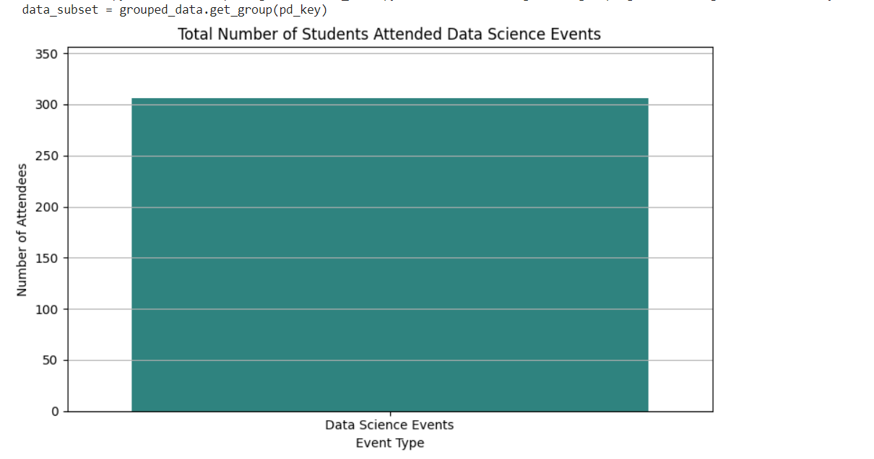

5.3 Salary Expectations Analysis

The analysis planned to examine the relationship between high CGPA, language proficiency, and salary expectations, indicating an intention to correlate academic performance with career aspirations

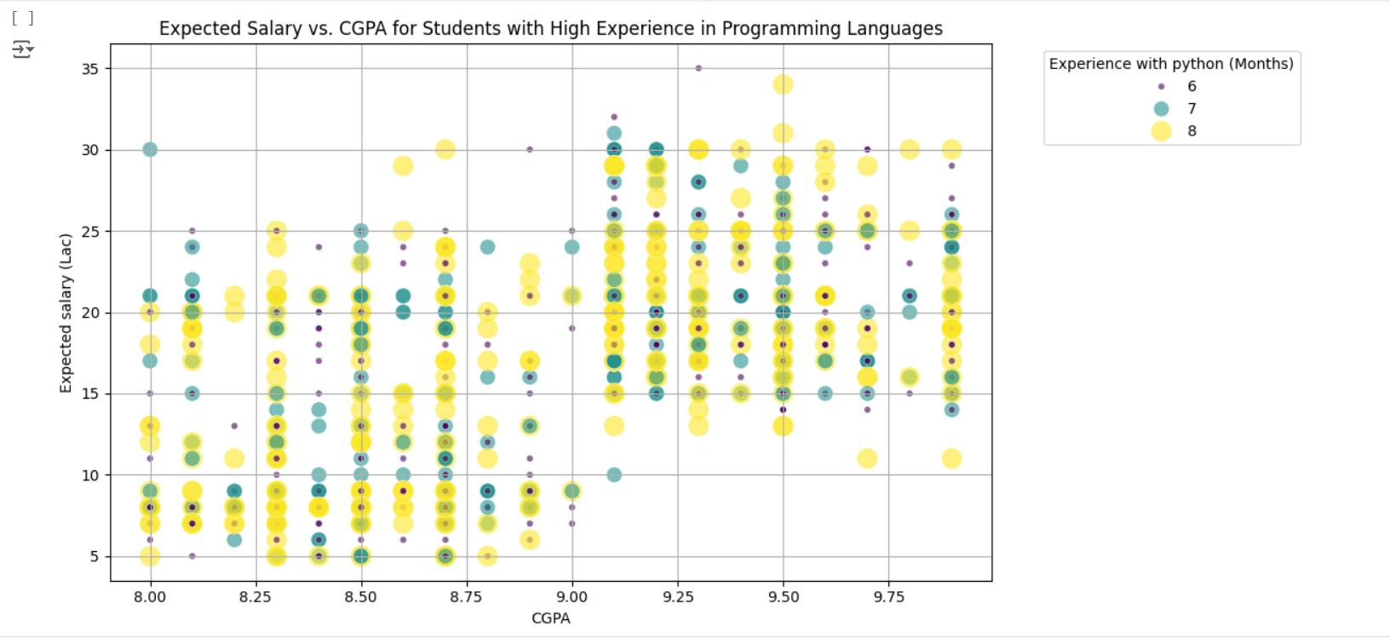

# **CONCLUSION**

*<Mention the how it will prove to be useful for the stakeholders and what can be the future scope>*

The study reveals a positive correlation between students' CGPA and their expected salaries, with students with higher CGPAs generally expecting higher salaries. Experience in programming languages, such as Python, also correlates with higher expected salaries. The study also found that students with similar CGPAs and experience levels have varying expected salaries, suggesting that other factors like internships, projects, networking, and personal aspirations may also influence salary expectations. The results emphasize the need for educational institutions to emphasize skill development in programming and other relevant areas, encouraging students to engage in projects, internships, and additional training to enhance their employability and salary prospects. Future research could include additional analyses examining soft skills, extracurricular activities, and industry-specific requirements to provide a more comprehensive understanding of career outcomes. Program effectiveness could be revealed by targeting specific programs or courses, helping guide curriculum development and resource allocation. Students should focus on maintaining strong academic performance, gaining practical experience through internships or projects, networking, and participating in relevant activities to further enhance their career prospects.

# **APPENDICES**

## Appendix A – Title

In the appendices section of the data analysis project report, additional supplementary materials are included to provide further detail, context, or support for the analysis and findings presented in the main body of the report. The appendices may include:

1. Data Table: Detailed tables containing raw or processed data used in the analysis, including variables, observations, and any relevant metadata.

2. Code Snippets: Extracts of code or scripts used for data cleaning, preprocessing, analysis, or visualization, particularly if the analysis involved programming languages such as Python, R, or SQL.

3. Data Visualization: Additional charts, graphs, or visualizations that provide further insight into the data or support specific findings discussed in the main report.

4. Model Documentation: Detailed documentation of any statistical models, machine learning algorithms, or predictive models used in the analysis, including model specifications, assumptions, and performance metrics.

5. Survey Instruments: If survey data was collected as part of the analysis, the survey instruments, questionnaires, or survey response data may be included in the appendices.

6. References and Citations: A list of references, citations, or sources consulted during the project, including academic papers, textbooks, articles, and online resources.

7.Glossary of Terms: Definitions and explanations of key terms, acronyms, or technical terminology used throughout the report to assist readers in understanding the analysis.

8. Data Sources: Information on the sources of data used in the analysis, including data providers, data collection methods, and any relevant data agreements or permissions.

9. Ethical Considerations: Documentation of ethical considerations or approvals obtained for the collection, use, and analysis of data, particularly if the project involved sensitive or personally identifiable information.

10. Additional Analysis: Any supplementary analysis, sensitivity analyses, or alternative scenarios considered but not included in the main report due to space constraints.

Including appendices allows readers to delve deeper into the details of the analysis and provides transparency and accountability in the research process. Appendices should be clearly labeled and referenced in the main body of the report as needed.